
/20
NAME: __________________________

Year 10 Science General: COMPARING REACTION RATES
In-class assessment

Magnesium is a reactive metal that reacts with hydrochloric acid to produce hydrogen gas (H₂) and salt magnesium chloride (MgCl₂).

Kate designed a series of investigations to explore a range of variables and how they affect the rate of reaction.
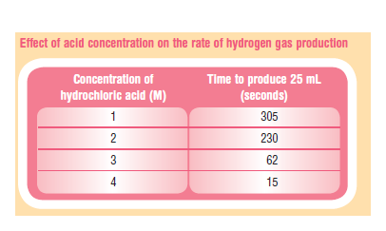
The data Kate collected is shown below.

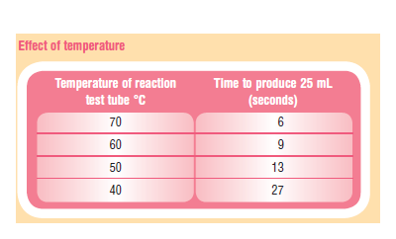

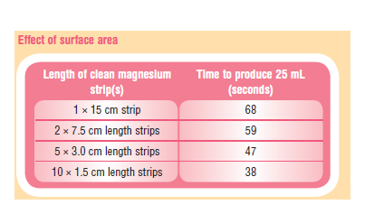

- Write the word equation for this reaction. (2 marks)

____________________________________________________________________________________________

- Graph the ‘Effect of acid concentration on the rate of hydrogen gas production’ in the most appropriate way.
(3 marks)

- What is the effect of acid concentration on the rate of production of the hydrogen gas? Explain this effect using scientific ideas you studied. (2 marks)

____________________________________________________________________________________________

____________________________________________________________________________________________

____________________________________________________________________________________________

____________________________________________________________________________________________

____________________________________________________________________________________________

____________________________________________________________________________________________

____________________________________________________________________________________________

- Graph the ‘Effect of surface area’ in the most appropriate way.
(3 marks)

- What is the effect of cutting the single strip of magnesium into more than one strip? Explain this effect on production of hydrogen gas using scientific ideas you have studied. (2 marks)

____________________________________________________________________________________________

____________________________________________________________________________________________

____________________________________________________________________________________________

____________________________________________________________________________________________

____________________________________________________________________________________________

____________________________________________________________________________________________

- Graph the ‘Effect of temperature’ in the most appropriate way.
(3 marks)

- What is the effect of temperature of the reactants on the rate of production of the hydrogen gas? Explain this effect using scientific ideas you have studied. (2 marks)

____________________________________________________________________________________________

____________________________________________________________________________________________

____________________________________________________________________________________________

____________________________________________________________________________________________

____________________________________________________________________________________________

____________________________________________________________________________________________

- What could Kate have done to make sure she was conducting a fair trial? (1 mark)

____________________________________________________________________________________________

____________________________________________________________________________________________

- In fireworks, many of the metals involved in the reactions to produce different chemical reactions and colours are supplied in a powder form. Explain, in terms of reaction rate, why a powder is used instead of one solid piece of each material. (2 marks)

____________________________________________________________________________________________

____________________________________________________________________________________________

____________________________________________________________________________________________

____________________________________________________________________________________________

____________________________________________________________________________________________

____________________________________________________________________________________________

